**NEURAL NETWORK DEEP LEARNING**

**ICP_4_SPRING24 ASSIGNMENT-4**

NAME : SANJANA MORTHA

UCM ID: 700747286

GITHUBLINK:

<https://github.com/sanjanamortha28/ICP_4_SPRING24>

Video Link: <https://github.com/sanjanamortha28/ICP_4_SPRING24/assets/70304377/c7faf0a8-7e88-4717-a154-5aacc4f85371>

Explained in class

1. Data Manipulation
2. Read the provided CSV file ‘data.csv’.

b.https://drive.google.com/drive/folders/1h8C3mLsso-R-sIOLsvoYwPLzy2fJ4IOF?usp=sharing

c.Show the basic statistical description about the data.

d. Check if the data has null values. i. Replace the null values with the mean

e. Select at least two columns and aggregate the data using: min, max, count, mean.

f. Filter the dataframe to select the rows with calories values between 500 and 1000.

g. Filter the dataframe to select the rows with calories values > 500 and pulse < 100.

h. Create a new “df_modified” dataframe that contains all the columns from df except for “Maxpulse”.

i. Delete the “Maxpulse” column from the main df dataframe

j. Convert the datatype of Calories column to int datatype.

k. Using pandas create a scatter plot for the two columns (Duration and Calories).

Output:

2. Linear Regression

a) Import the given “Salary_Data.csv”

b) Split the data in train_test partitions, such that 1/3 of the data is reserved as test subset.

c) Train and predict the model.

d) Calculate the mean_squared error

e) Visualize both train and test data using scatter plot.

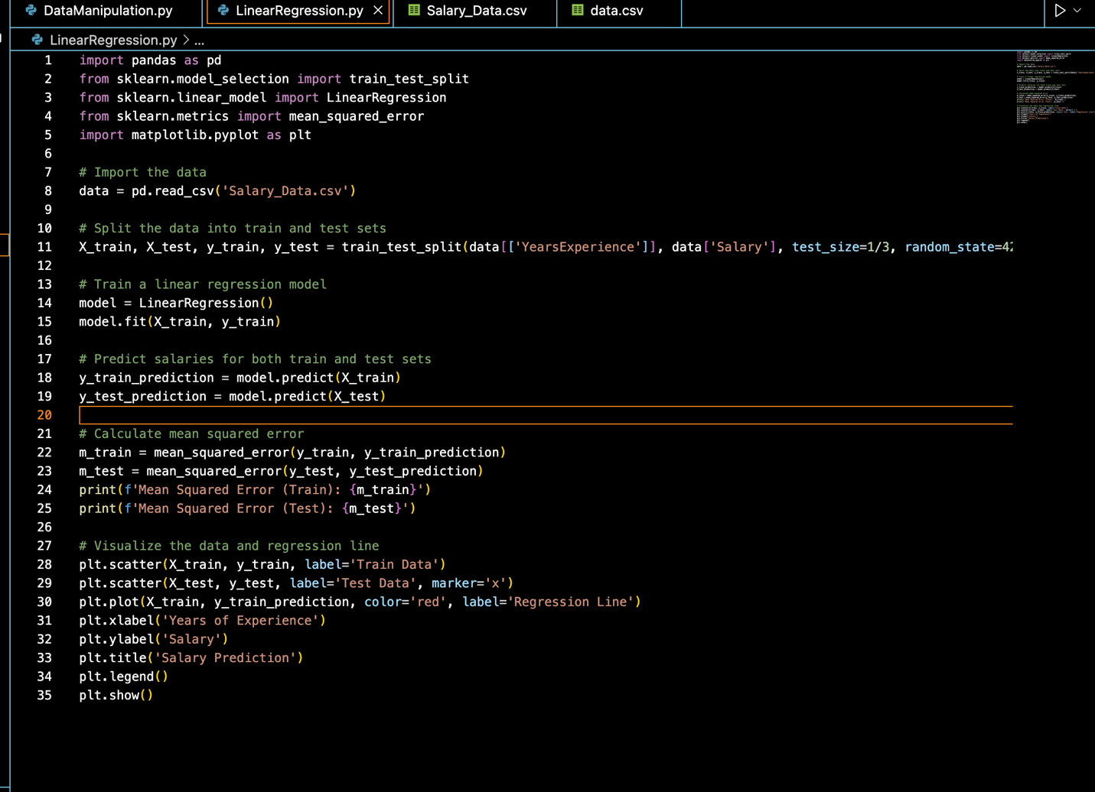

Output:



